LEARning management system FOR SYS college

**zohaib waqar**

ex dev & Technical business analyst

BUSINESS REQUIREMENT DOCUMENT

07 may 2025

Table of Contents

**Author Change Control & Approvers2**

**Executive Summary3**

**Glossary3**

**User Personas4**

**Business Goals4**

**Project Overview & Objectives4**

Overview4

Objectives4

**Project Scope5**

In Scope5

Out of Scope5

**Success Criteria5**

**Current State5**

**Target State5**

**RAID (Risks, Assumptions, Issues, Dependencies)6**

**Major Requirements6**

**Business Rules8**

**Data Privacy & Security Requirements8**

**Accessibility Considerations** **9**

**Business Process Flow9**

**Reports & KPI9**

**Reference Documents10**

**Project Schedule (High-Level Milestones)10**

1. **Author Change Control & Approvers**

|  |  |  |  |  |
| --- | --- | --- | --- | --- |
| # | version | Date | Author | description |
| 1 | 1.0 | 07 May 2025 | Zohaib Waqar | Initial Draft |

**Reviewed By:** [Reviewer Name Here]

**Approved By:** [Approver Name Here]

1. **Executive Summary**

This BRD outlines the business needs, goals, and high-level requirements for implementing a modern Learning Management System (LMS) at Sys College. This system aims to support strategic objectives such as improving teaching quality, increasing student engagement, and enabling digital transformation across campuses. The document is informed by stakeholder interviews and aligned with institutional priorities.

1. **Glossary**

|  |  |  |
| --- | --- | --- |
| # | Term | definition |
| 1 | LMS | Learning Management System |
| 2 | SIS | Student Information System |
| 3 | RBAC | Role-Based Access Control |
| 4 | SSO | Single Sign-On |
| 5 | KPI | Key Performance Indicators |

1. **User Personas**
   1. **Lecturers / Tutors**: Deliver course content and manage assessments
   2. **Students**: Consume learning materials, submit assignments
   3. **Admin Staff**: Manage enrollments, scheduling, records
   4. **Department Heads**: Monitor academic progress, resource utilization
   5. **IT Staff**: Manage integration, security, infrastructure
   6. **Executives (VPs)**: Monitor KPIs, strategic alignment, funding
2. **Business Goals**
   1. Deliver a superior student learning experience
   2. Increase teaching quality and academic effectiveness
   3. Support data-driven decision-making across departments
   4. Streamline academic and administrative operations
   5. Enable digital and remote learning across campuses
3. **Project Overview & Objectives**
   1. **Overview**

The LMS project is part of Sys College's strategic vision to lead in teaching excellence. The system will centralize learning activities, enable performance tracking, and improve communication among faculty, students, and administrators.

* 1. **Objectives**
     1. Implement a cloud-based LMS with role-based access
     2. Provide integration with SIS, Active Directory, and HRMS
     3. Enable dashboards for monitoring engagement and performance
     4. Support mobile and offline access to content
     5. Automate grading, attendance, and notifications

The system’s high-level data flow and boundaries are illustrated in the System Context Diagram (**see Appendix ‘A’**)

1. **Project Scope**
   1. **In Scope**
      1. Centralized content management and learning modules
      2. Assignment submissions and grading workflows
      3. Real-time dashboards and analytics
      4. Mobile and offline access
      5. Integration with core systems (SIS, AD)
      6. Role-based access and permissions
   2. **Out of Scope**
      1. Physical infrastructure upgrades
      2. Third-party course content creation
      3. External certification or accreditation platforms
2. **Success Criteria**
   1. **85%** adoption rate within one academic term
   2. Reduction in grading and reporting time by **40%**
   3. Student satisfaction score improvement by **25%**
   4. **Real-time visibility** of academic KPIs
3. **Current State**
   1. Fragmented tools: emails, shared drives, physical materials
   2. Manual tracking of attendance, grading, and progress
   3. No unified view of course performance or engagement
4. **Target State**
   1. Centralized, secure LMS platform with integrated tools
   2. Automated workflows and unified communication channels
   3. Role-specific dashboards for faculty, students, and executives
5. **RAID (Risks, Assumptions, Issues, Dependencies)**

|  |  |
| --- | --- |
| Type | Description |
| Risk | Resistance to change from senior faculty |
| Assumption | Staff and students will have basic digital literacy |
| Issue | Integration delays with legacy systems |
| Dependency | SIS, HRMS, AD system compatibility |

1. **Major Requirements**

The following section outlines the major system requirements for the LMS project using the **MoSCoW** **prioritization** method, along with the corresponding stakeholder sources. The system’s visual breakdown of the prioritization is illustrated in MoSCoW Prioritization Matrix (**see Appendix ‘B’**)

* 1. **Must Have**

These are critical requirements without which the system will not function as intended.

|  |  |
| --- | --- |
| Requirement | Source |
| Centralized course content repository for all departments | Academic Staff, Students |
| Assignment submission and automated grading workflows | Academic Staff, Students |
| Automated notifications for deadlines, grades, and announcements | Academic Staff, Students |
| Mobile-responsive design with offline access capability | Students |
| Role-Based Access Control (RBAC) to manage permissions | IT Department |
| Integration with Student Information System (SIS) and Active Directory (AD) | IT Department |
| Secure authentication with SSO and MFA | IT Department, Executives |
| Real-time dashboards for student performance and faculty activity | Department Heads, Executives |

* 1. **Should Have**

Important features that add significant value but are not essential at initial rollout.

|  |  |
| --- | --- |
| Requirement | Source |
| Attendance tracking through login/session logs | Admin Staff, Academic Staff |
| Course completion tracking for students | Academic Managers, Students |
| Messaging/chat system within the platform | Students, Academic Staff |
| Document version control for uploaded materials | Academic Staff |
| Basic plagiarism detection integration | Academic Staff |

* 1. **Could Have**

Desirable features that can enhance the user experience if time and budget permit.

|  |  |
| --- | --- |
| Requirement | Source |
| Peer review and collaborative group project tools | Students |
| Gamification elements (badges, leaderboards) | Students |
| AI-based recommendations for learning content | Executives |

* 1. **Won't Have (for now)**

These features are out of scope for the initial phase but may be considered in future enhancements.

|  |  |
| --- | --- |
| Requirement | Source |
| Integration with third-party MOOC platforms (e.g., Coursera) | Project Scope Decision |
| Fully automated course recommendation engine | Executive Interview, marked as future enhancement |
| External accreditation or certification workflows | Executive Team, marked out-of-scope |

The use case diagram (**see Appendix ‘C’**) outlines the major functional interactions between system users and the LMS. It highlights what actions each user role (e.g., Student, Faculty, Admin Staff, Executives, IT Department) can perform in the system, such as managing enrollment, submitting assignments, generating reports, and accessing materials.

**Use Case Diagram**

**Common Use Cases (All Roles)**

* **Register** Allows users to create an account in the LMS (or be provisioned through integrated systems).
* **Login** Enables secure access to the LMS using credentials, often authenticated via Active Directory.

**Admin Staff**

* **Enroll Student:** Register new students into the appropriate courses and academic sessions.
* **Manage Schedule:** Create and maintain class schedules, exam timetables, and resource allocations.
* **Monitor Compliance:** Track attendance, course completion, and policy adherence across departments.

**Faculty**

* **Create Course:** Set up a new course in the LMS with basic structure and metadata.
* **Manage Course:** Update course info, enrollment limits, session plans, and timelines.
* **Upload Content:** Add learning materials such as slides, documents, and videos.
* **Manage Content:** Organize, update, or archive existing course content.
* **Manage Grades:** Enter, update, and release student grades and feedback.

**Student**

* **View Content:** Access course materials, lectures, notes, and readings.
* **View Courses:** See a personalized dashboard of all enrolled courses.
* **Submit Assignment:** Upload assignments and track submission status and deadlines.

**Department Heads**

* **View Dashboard:** Access real-time data on faculty activity, student performance, and course status.
* **Analyze Performance:** Review aggregated analytics to identify academic trends, gaps, and improvement areas.

1. **Business Rules**
   1. Only faculty can modify course content
   2. Students can view only their enrolled modules
   3. Attendance must be auto-logged for every session
2. **Data Privacy & Security Requirements**
   1. Compliance with GDPR and national education data policies
   2. Multi-factor authentication and SAML-based SSO
   3. Encrypted data storage and secure user sessions
3. **Accessibility Considerations**
   1. WCAG 2.1 compliant UI for visually impaired users
   2. Keyboard navigability and screen reader compatibility
   3. Mobile responsiveness
4. **Business Process Flow**

The Business Process Flow Diagram (**see Appendix ‘C’**) illustrates the end-to-end business process flow for the LMS at Sys College. It represents how various user roles interact with the system throughout the academic lifecycle, from course creation and enrollment to assignment submission, grading, and performance reporting. This flow integrates key external systems like SIS, Turnitin, and AD for seamless automation and secure access.

1. **Reports & KPI**
   1. Faculty performance dashboard
   2. Student engagement & retention reports
   3. Real-time grading summaries
   4. Assignment submission compliance
2. **Reference Documents**
   1. [Requirements Elicitation Document (dated: 03 May 2025)](https://github.com/ZohaibWaqarMalik/Technical-Business-Analyst-Projects/blob/main/02%20-%20LMS-SysCollege/01%20-%20Requirements%20Elicitation/01%20-%20Requirement%20Elicitation.pdf)
   2. [Stakeholder Interview Summaries (dated: 05 May 2025)](https://github.com/ZohaibWaqarMalik/Technical-Business-Analyst-Projects/blob/main/02%20-%20LMS-SysCollege/01%20-%20Requirements%20Elicitation/02%20-%20Requirements%20Elicitation%20-%20Questionaries.pdf)
   3. Appendix A: System Context Diagram
   4. Appendix B: MoSCoW Prioritization Matrix
   5. Appendix C: Business Process Flow
3. **Project Schedule (High-Level Milestones)**

|  |  |
| --- | --- |
| Milestone | Target Date |
| BRD Approval | [Insert] |
| System Design Completion | [Insert] |
| Development Start | [Insert] |
| User Testing | [Insert] |
| Go-live | [Insert] |

**Appendix A**

**SYSTEM CONTEXT DIAGRAM**

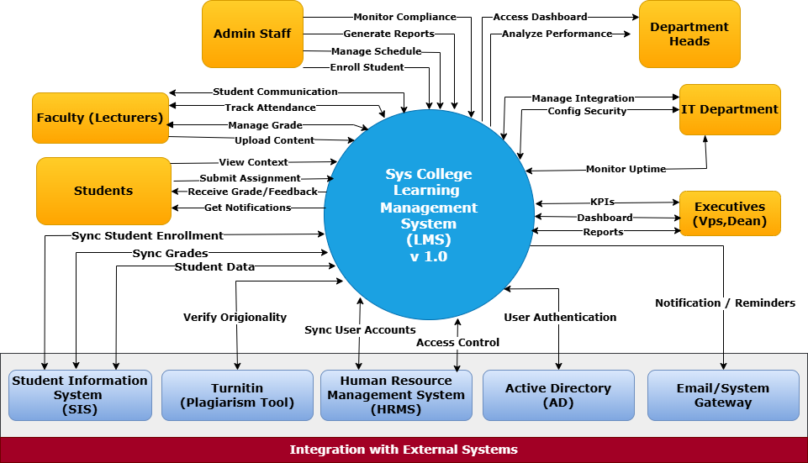

Fig A1: System Context Diagram

In the context diagram, the central system is represented as a single unit, with surrounding external entities connected via labeled data flows. These data flows indicate the main interactions, such as user requests, data submissions, or third-party API calls.

**Appendix B**

**MOSCOW PRIORITIZATION MATRIX**

|  |  |
| --- | --- |
| **MUST HAVE** | **SHOULD HAVE** |
| 1. Centralized course content repository for all departments 2. Assignment submission and automated grading workflows 3. Role-Based Access Control (RBAC) to manage permissions 4. Integration with Student Information System (SIS) and Active Directory (AD) 5. Real-time dashboards for student performance and faculty activity 6. Automated notifications for deadlines, grades, and announcements 7. Mobile-responsive design with offline access capability 8. Secure authentication with SSO and MFA   **Source:** Department Heads, Executives, Academic Staff, Students, IT Department | 1. Attendance tracking through login/session logs 2. Course completion tracking for students 3. Messaging/chat system within the platform 4. Document version control for uploaded materials 5. Basic plagiarism detection integration   **Sources:** Academic Staff, Admin Staff, Academic Managers, Students |
| **COULD HAVE** | **WON’T HAVE** |
| 1. Peer review and collaborative group project tools Gamification elements (badges, leaderboards) Source: Students 2. AI-based recommendations for learning content   **Source:** Students, Executives | 1. Integration with third-party MOOC platforms (e.g., Coursera) 2. Fully automated course recommendation engine 3. External accreditation or certification workflows   **Source:** Source: Project Scope Decision, Executive Team, marked out-of-scope |

Fig B1: MoSCoW Prioritization Matrix

This matrix categorizes business requirements using the MoSCoW method (Must Have, Should Have, Could Have, and Won’t Have) to clearly indicate priority and aid in project scope management.

**Appendix C**

**USE CASE DIAGRAM**

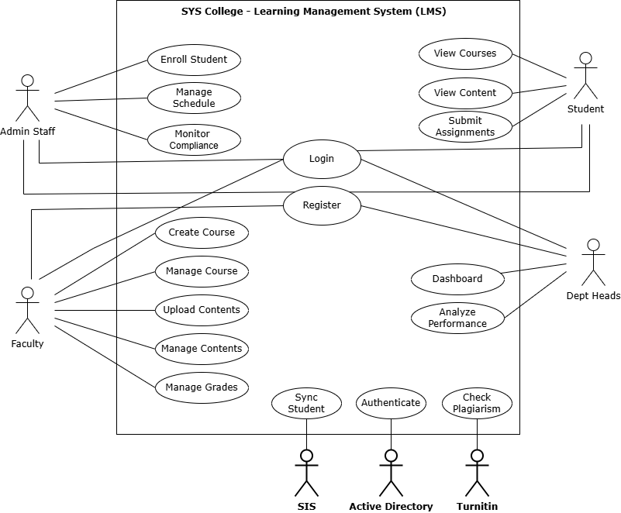

Fig C1: Use Case Diagram

This diagram visualizes the sequential interaction of faculty, admin staff, students and dept heads within the LMS, including integration points with external services such as SIS, Turnitin, and Active Directory.

**Appendix D**

**BUSINESS PROCESS FLOW**

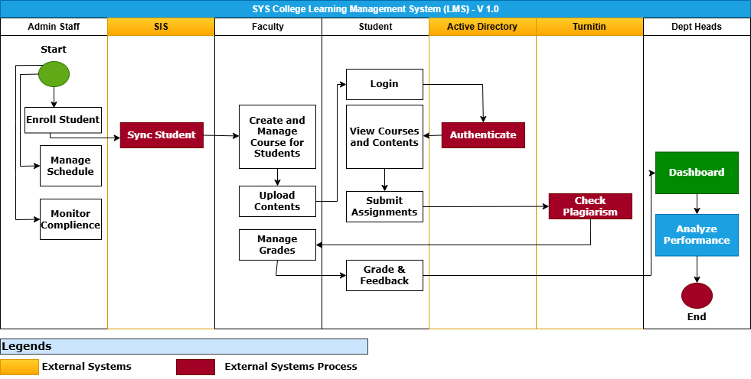

Fig D1: Business Process Flow – Swim Line Diagram

This diagram visualizes the sequential interaction of faculty, admin staff, students and dept heads within the LMS, including integration points with external services such as SIS, Turnitin, and Active Directory.